**Qua.1 -> What is software? What is software engineering?**

**Ans.** Software isset of instruction provided to the system for execution. Software Engineering is a systematic approach to designing, developing, testing and maintaining software using engineering procedure oriented programming.

-------------------------------------------------------------------------------------------------------------------------

**Qua.2 -> Explain types of software**.

**Ans.** There are two main types of software in software engineering,

1. **System Software:-**

System Software is type of software were manages computer hardware and provides a platform for other software to run.

* e.g.,

Operating systems, device drivers and language processors etc.

1. **Application Software:-**

Application software is perform specific tasks for users or other applications.

* e.g.,

Web browsers, business software, games, mail etc.

-----------------------------------------------------------------------------------------------------------------------------------

**Qua.3 -> What is SDLC? Explain each phase of SDLC.**

**Ans.** Software development life cycle is a step-by-step approach to develop any product or software with high quality within intended time line & budget.

There are six types of SDLC,

1. **Planning :-** (Requirement Gathering {what})

Define project scope, goals, objectives and timeline. Identify potential risks and creating a plan.

* Creating a detailed project timeline with milestone and deadline
* Establishing communication channels and protocols among team members.

1. **Analysis :-** (How)

Analysis is the process of gathering information and defining project requirements.

* Conduct surveys, analyse existing systems and research industry trends
* Identify the critical requirements and prioritize them based on business value

1. **Designing :-** (DFD, ER Diagram, Flow chart, Use case)

Designing is create software architecture, user interface and detailed specifications for each component. Choose the tools for development.

* Defining the overall structure and high level components of the software
* Designing the visual layout and user interactions for the software

1. **Implementation / Coding / Building :-** (h/w, s/w, resources)

Implementation in SDLC is the process of turning design into working software or functional software.

* **Code :** Developers write code based on design specifications and coding standards
* **Building :** Code is compiled and linked to create executable software code.
* Software is customized to function in the specific technology

1. **Testing :-** (QA)

Testing in SDLC is a critical phase to identify and fix defects, ensuring software quality, match user expectations and is user friendly.

* Verify all functional and non-functional requirement

1. **Maintenance :-**

Maintenance in SDLC is the ongoing process of updating and supporting software after deployment.

* Fixing bugs and errors
* Modifying the software to changes in the technology
* New features or improving performance

-----------------------------------------------------------------------------------------------------------------------------------

**Qua.4 -> What is DFD? Create a DFD diagram on Flipkart.**

**Ans.** DFDis the abbreviation for **Data Flow Diagram.** The flow of data of a system or process is represented by DFD.

* DFD Have four components:

1. Process
2. Data Store
3. Data Flow
4. External Entity

* e.g.,
* Level – 0 DFD :-

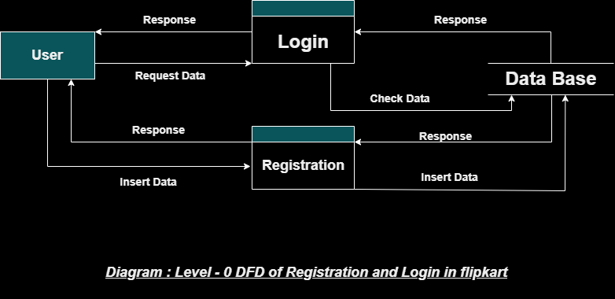

* Level – 1 DFD :-

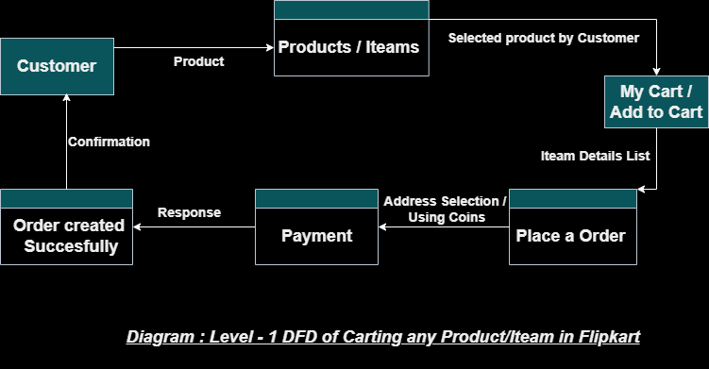

* Level – 2 DFD :-

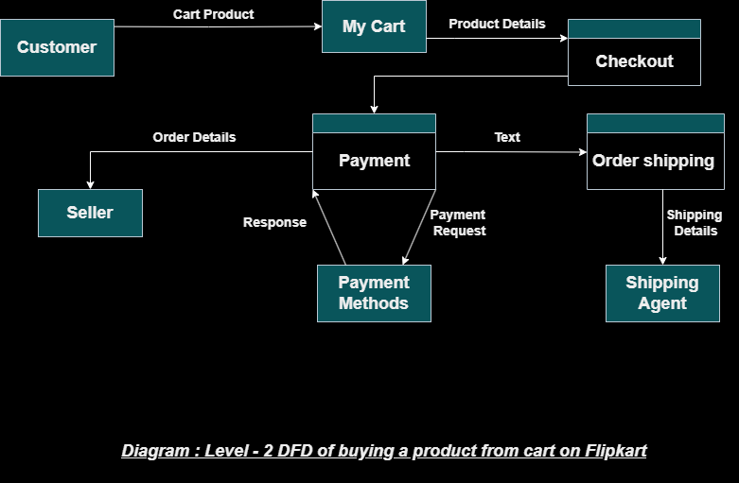

------------------------------------------------------------------------------------------------------------------------------------

**Qua.5 -> What is Flow chart? Create a flowchart to make addition of two numbers.**

**Ans.** Flow chart is a visual representation of a process or work flow. It uses different shapes to represent steps, start/end, Arrows, Input/Output, Process, Decision and actions connected by arrows

to show of the process or flow.

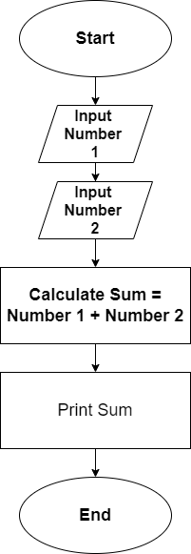

* e.g.,

Use Cases:

Step No.1 :- Start: The beginning of the flowchart.

Step No.2 :- Get the Input Number 1 from the user.

Step No.3 :- Get the Input Number 2 from the user.

Step No.4 :- Calculate Sum: Add the two input numbers and store the result in a variable called "Sum."

Step No.5 :- Display show the calculated sum to the user.

Step No.6 :- Stop: The end of the flowchart.

------------------------------------------------------------------------------------------------------------------------------------

**Qua.6 -> What is Use case Diagram? Create a use-case on bill payment on paytm.**

**Ans.** Ause case diagram is a visual representation of how users (actors)interact with a system to achieve specific goals.

* e.g.,

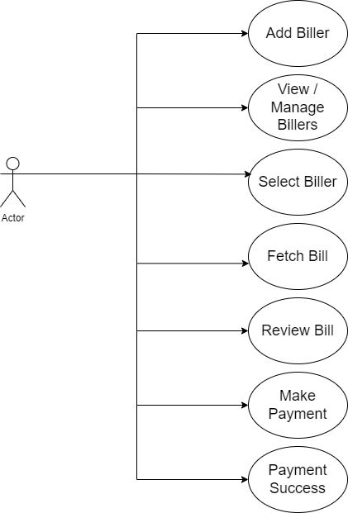

Use Cases:

Step No.1 :- Add Biller: User adds a new biller (e.g., electricity, water, gas) to their account.

Step No.2 :- View/Manage Billers: User views their list of saved billers and can edit or delete them.

Step No.3 :- Select Biller: User chooses the biller for whom they want to pay a bill.

Step No.4 :- Fetch Bill: Paytm retrieves the latest bill amount for the selected biller.

Step No.5 :- Review Bill: User reviews the bill details before proceeding to payment.

Step No.6 :- Make Payment: User selects a payment method (e.g., Paytm wallet, UPI, debit card) and completes the payment.

Step No.7 :- Payment Success: Paytm confirms successful payment and generates a receipt.

------------------------------------------------------------------------------------------------------------------------------------